* **Activity 5:**

Creating Three-Way Joins with the ON Clause

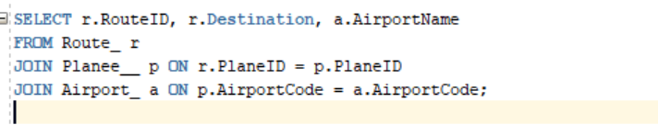

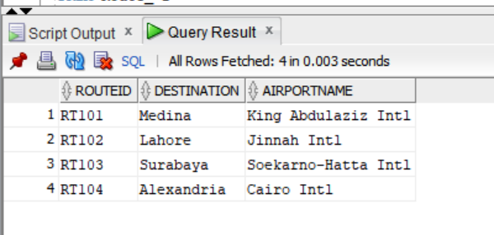OUTPUT:

Three-Way Join with the USING Clause

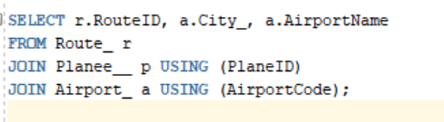

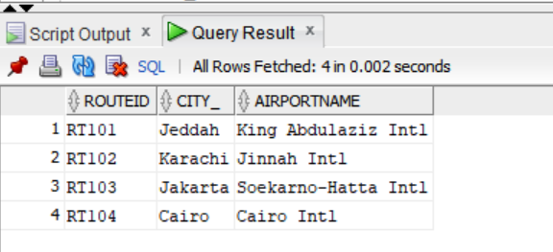OUTPUT: